**Input Explanation:**

Here we are using a text file as an input to our program. The first line of the text file contains the number of edges and vertex. The next lines of the text file contains the connectivity between two vertices. If the vertex 2 and vertex 3 is connected the we write 2 3 in the text file as a source destination pair.

**Input Graph1 (Diagram) :**

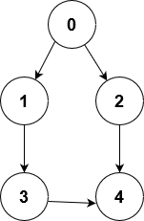

**Input Graph1 (Text file representation):**

5 5

0 1

0 2

1 3

3 4

4 2

**Input Graph 2 (Diagram):**

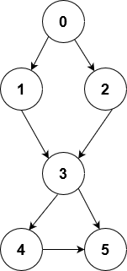

**Input Graph1 (Text file representation):**

8 6

0 1

0 2

1 2

3 1

3 2

3 4

3 5

4 5

**Output:**

No. of edge: 8

No. of vertices: 6

The adjacency matrix is:

0 1 1 0 0 0

0 0 1 0 0 0

0 0 0 0 0 0

0 1 1 0 1 1

0 0 0 0 0 1

0 0 0 0 0 0

Vertices reached from 0 :

0 1 2

Vertex 0 can not be considered as initiator

Vertices reached from 1 :

1 2

Vertex 1 can not be considered as initiator

Vertices reached from 2 :

2

Vertex 2 can not be considered as initiator

Vertices reached from 3 :

3 1 2 4 5

Vertex 3 can not be considered as initiator

Vertices reached from 4 :

4 5

Vertex 4 can not be considered as initiator

Vertices reached from 5 :

5

Vertex 5 can not be considered as initiator

The Graph is a dis-connected graph